AI Job Growth and Market Analysis
MSDS670 - Data Visualization Final Project
Sriram Devaraju
Jason Koenig
Regis University
March 2026

Introduction
The demand for jobs in artificial intelligence is quickly increasing in various industries. It can be difficult to track trends in demand for job openings with time and salary differences among different experience levels or the key technical skills associated with that type of work. Data visualization allows large amounts of data to be displayed in easy-to-understand ways. By creating charts and graphs, it will be easier to spot hiring patterns, identify differences in salary, and understand what skills are needed in your chosen profession.

Research Question
This project analyzes job postings for artificial intelligence (AI) to help provide answers to two questions:
How have AI job postings changed over time, and how do experience level and required technical skills influence salary and hiring patterns in the AI job market?

Data
The dataset for this study contains thousands of job listings for artificial intelligence specialists.
This data includes the listing's date of posting, salary (in USD), experience required, and company location along with a list of the technical skills required for the job. Using the job listing dates, a time-based chart was created to show trends in the demand for hourly employees over time. The salary data was used to compare how much a worker will earn based on their level of experience.
The skills required were used to count the number of times an applicant would be classified as an employee with expertise using a particular technology. This dataset can be analysed in order to determine hiring trends, the difference in salary, and the top 10 AI specialty required for the job.
Methodology
The analysis was conducted in Python using the pandas and matplotlib libraries. The use of pandas allowed for cleaning and organizing the data, while matplotlib allowed for the creation of visualizations. To demonstrate demand trends over time, job postings were grouped by month to create a time-series line graph showing changes in demand over time. Furthermore, average salary for each level of experience was calculated to create a bar graph of comparison between average salaries at each experience level. The skills column was split into distinct skill values which were then counted to determine the most frequently requested AI skills. All the visualizations were created with matplotlib to meet project requirements.
Results
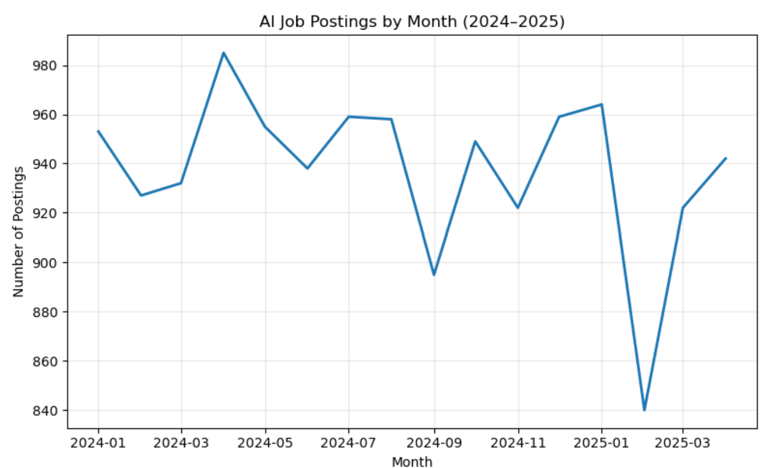
Figure 1 – AI Job Postings by Month
A line graph shows how many AI job advertisements were posted each month from January 2024 through December 2025. There were many jobs advertised each month, showing that there is still a lot of demand for AI jobs. The biggest number of ads was in April 2024, while there were fewer ads in January and February 2025. Generally, the trend had no spikes; it demonstrates continued interest.
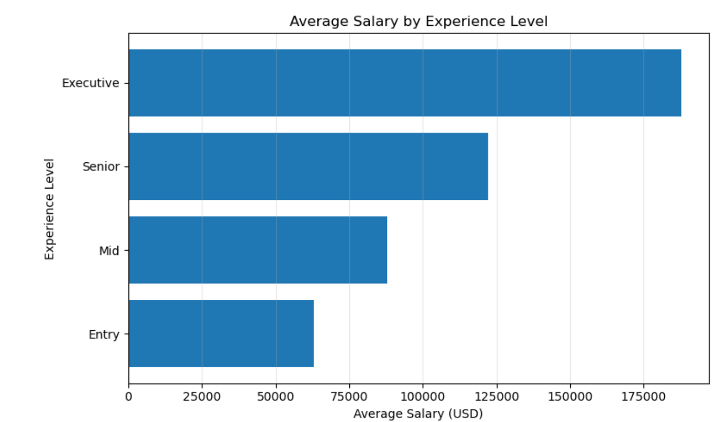
Figure 2 – Average Salary by Experience Level
According to the bar chart, different experience levels also have differing average salaries. The lowest average salary is for entry-level positions, and the highest average salary is for executive level positions. The average salary increases from entry to mid, to senior, to executive. Therefore, as experience level changes in an AI job, so too does the average salary of those jobs.
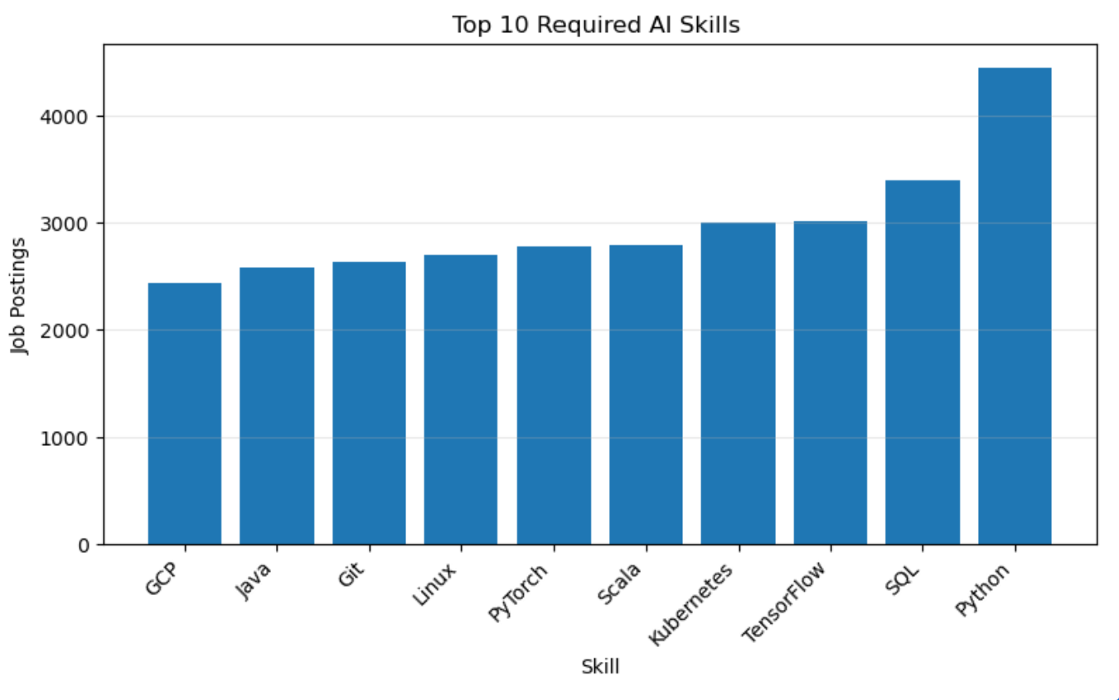
Figure 3 – Top 10 Required AI Skills
The skills chart displays the ten most common skills requested in AI job postings. Python is the most frequent, followed by SQL and TensorFlow. Most of the top skills are programming related, machine learning and cloud-based technologies. This indicates that an employer will demand a high level of technical skills when hiring for AI positions.
Conclusion
The analysis of AI job demand showed that there had been continued demand throughout the period analysed in the dataset provided. There were many high-level job postings over all months covered by this dataset which indicated that there was a stable hiring demand across all the AI jobs listed in this dataset. Salary increases with respect to years of experience, which means that advanced skill sets and seniority (leadership positions) require higher salaries accordingly. The top 3 skills that were requested were: Python (59%), SQL (27%) and TensorFlow (16%), showing how important programming knowledge and machine learning skills are for obtaining success in AI jobs.
This project was able to demonstrate how effective data visualization can be in conveying and explaining trends in the labour market and therefore assisting employers in understanding the patterns of their hiring in AI positions.
References
Sajjad, B. (2025). Global AI job market and salary trends 2025 [Data set]. Kaggle. https://www.kaggle.com/datasets/bismasajjad/global-ai-job-market-and-salary-trends-2025

